**Laporan Praktikum**

**Pemrograman Web 1**

**Dosen pengampu : Yati Nurhayati S.Kom., M.Kom**



**Nama : Bayu Imantoro**

**NIM : 20230810089**

**Kelas : TINFC – 2023 – 04**

**Teknik Informatika**

**Fakultas Ilmu Komputer**

**Universitas Kuningan**

PRAKTIKUM

M7-1.html

<!doctype html>

<html lang="en">

  <head>

    <meta charset="utf-8">

    <meta name="viewport" content="width=device-width, initial-scale=1">

    <title>Bootstrap demo</title>

    <script src="js/jquery-3.7.1.min.js"></script>

    <link rel="stylesheet" href="css/bootstrap-reboot.min.css">

  </head>

  <body>

    <h1>Hello, world!</h1>

    <script src="js/bootstrap.bundle.min.js"></script>

  </body>

</html>

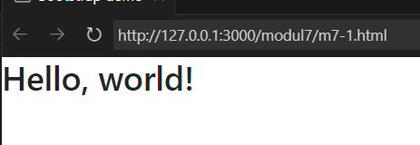

Analisis

Memunculkan Hello, World! Dengan menggunakan Bootstrap

Index.html

<!DOCTYPE html>

<html lang="en">

  <head>

    <meta charset="UTF-8" />

    <meta name="viewport" content="width=device-width, initial-scale=1.0" />

    <title>Bootstrap demo</title>

    <link rel="stylesheet" href="css/bootstrap.min.css" />

    <link href="css/style.css" rel="stylesheet" />

  </head>

  <body>

    <!--navbar-->

    <nav class="navbar navbar-expand-lg navbar-dark bg-primary">

      <div class="container-fluid">

        <a class="navbar-brand" href="#">FAKULTAS ILMU KOMPUTER</a>

        <button

          class="navbar-toggler"

          type="button"

          data-bs-toggle="collapse"

          data-bs-target="#navbarSupportedContent"

          aria-controls="navbarSupportedContent"

          aria-expanded="false"

          aria-label="Toggle navigation"

        >

          <span class="navbar-toggler-icon"></span>

        </button>

        <div class="collapse navbar-collapse" id="navbarSupportedContent">

          <ul class="navbar-nav me-auto mb-2 mb-lg-0">

            <li class="nav-item">

              <a class="nav-link active" aria-current="page" href="#"

                >Beranda</a

              >

            </li>

            <li class="nav-item">

              <a class="nav-link" href="#">Profil</a>

            </li>

            <li class="nav-item dropdown">

              <a

                class="nav-link dropdown-toggle"

                href="#"

                role="button"

                data-bs-toggle="dropdown"

                aria-expanded="false"

              >

                Fasilitas

              </a>

              <ul class="dropdown-menu">

                <li><a class="dropdown-item" href="#">Action</a></li>

                <li><a class="dropdown-item" href="#">Another action</a></li>

                <li><hr class="dropdown-divider" /></li>

                <li>

                  <a class="dropdown-item" href="#">Something else here</a>

                </li>

              </ul>

            </li>

            <li class="nav-item">

              <a class="nav-link">PMB</a>

            </li>

          </ul>

        </div>

      </div>

    </nav>

    <!--end navbar-->

    <!--jumbotron-->

    <div class="jumbotron jumbotron-fluid">

      <div class="container"></div>

    </div>

    <!--end jumbotron-->

    <!--konten-->

    <form class="row g-3">

      <div class="col-md-6">

        <label for="inputEmail4" class="form-label">Email</label>

        <input type="email" class="form-control" id="inputEmail4" />

      </div>

      <div class="col-md-6">

        <label for="inputPassword4" class="form-label">Password</label>

        <input type="password" class="form-control" id="inputPassword4" />

      </div>

      <div class="col-12">

        <label for="inputAddress" class="form-label">Address</label>

        <input

          type="text"

          class="form-control"

          id="inputAddress"

          placeholder="1234 Main St"

        />

      </div>

      <div class="col-12">

        <label for="inputAddress2" class="form-label">Address 2</label>

        <input

          type="text"

          class="form-control"

          id="inputAddress2"

          placeholder="Apartment, studio, or floor"

        />

      </div>

      <div class="col-md-6">

        <label for="inputCity" class="form-label">City</label>

        <input type="text" class="form-control" id="inputCity" />

      </div>

      <div class="col-md-4">

        <label for="inputState" class="form-label">State</label>

        <select id="inputState" class="form-select">

          <option selected>Choose...</option>

          <option>...</option>

        </select>

      </div>

      <div class="col-md-2">

        <label for="inputZip" class="form-label">Zip</label>

        <input type="text" class="form-control" id="inputZip" />

      </div>

      <div class="col-12">

        <div class="form-check">

          <input class="form-check-input" type="checkbox" id="gridCheck" />

          <label class="form-check-label" for="gridCheck"> Check me out </label>

        </div>

      </div>

      <div class="col-12">

        <button type="submit" class="btn btn-primary">Sign in</button>

      </div>

    </form>

    <!--end konten-->

    <!--footer-->

    <div

      class="footer"

      style="background-color: darkblue; color: white; padding: 20px"

    >

      &copy; FAKULTAS ILMU KOMPUTER - UNIVERSITAS KUNINGAN | 2022

    </div>

    <!--end footer-->

    <script src="js/bootstrap.bundle.min.js"></script>

  </body>

</html>

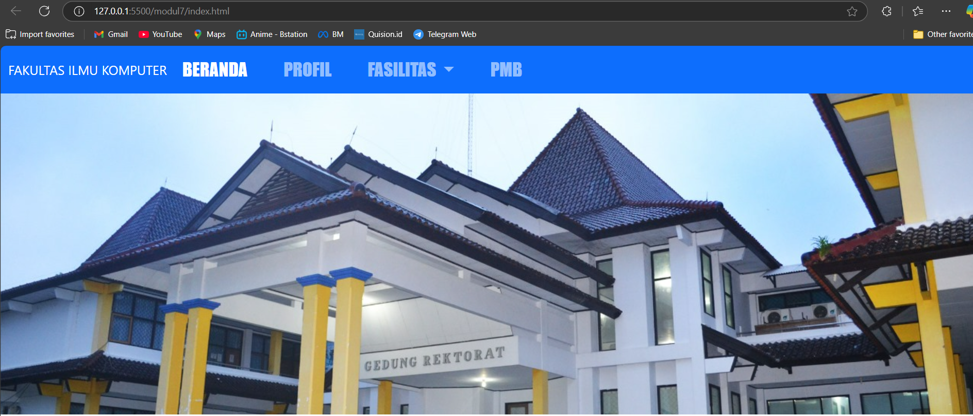

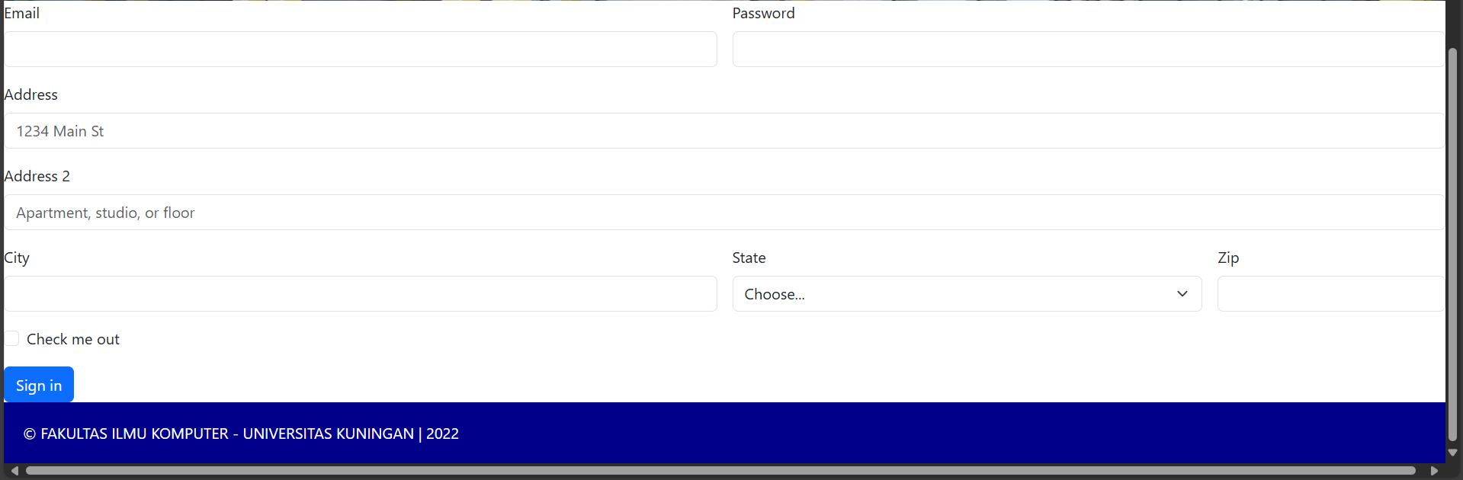

Analisis

Mempelajari bootstrap dalam desain web dan membuat web Faklultas Ilmu Komputer dengan menggunakan bootsrap yang berisi dalam web nya seperti pada gambar tersebut